C PROGRAMMING TO FIND SUM OF ELEMENTS IN THE GIVEN ARRAY

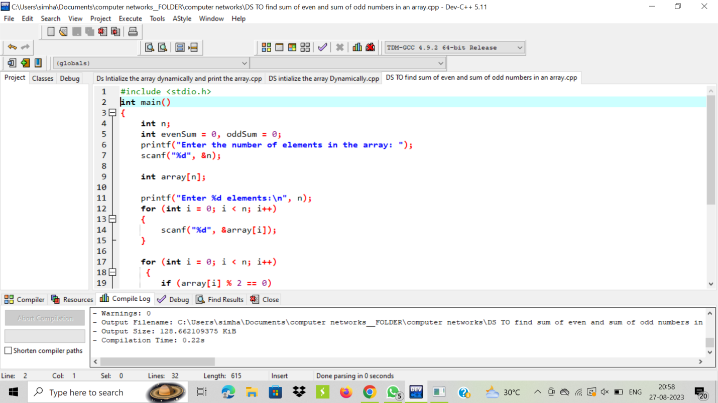

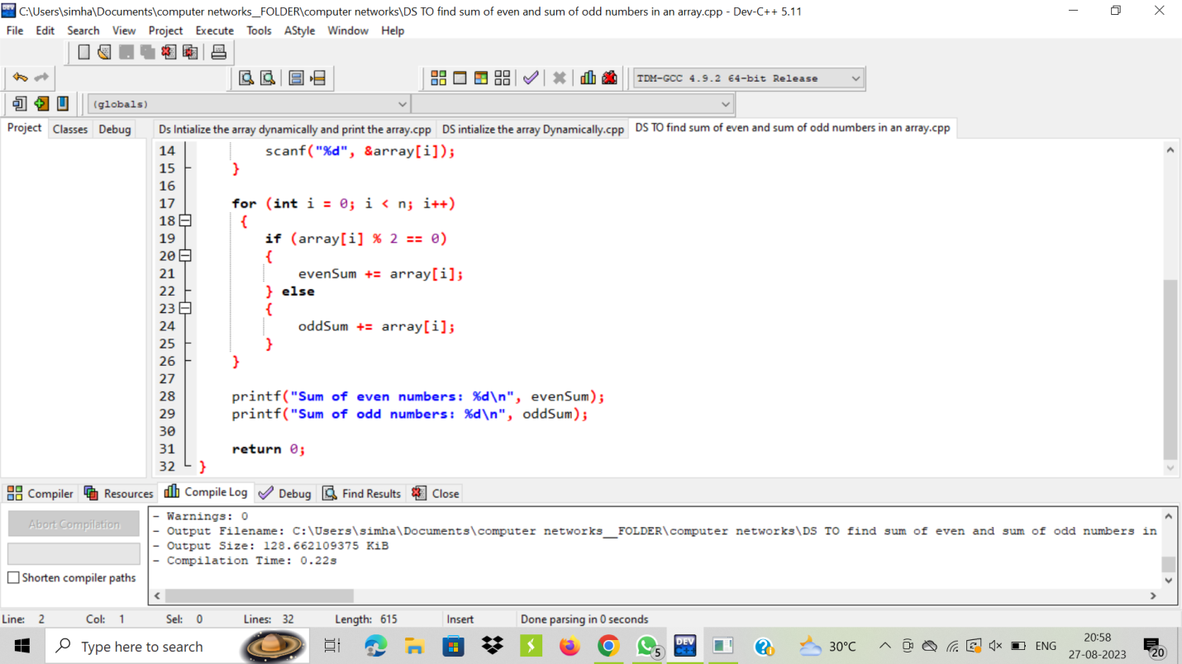

OUTPUT:

